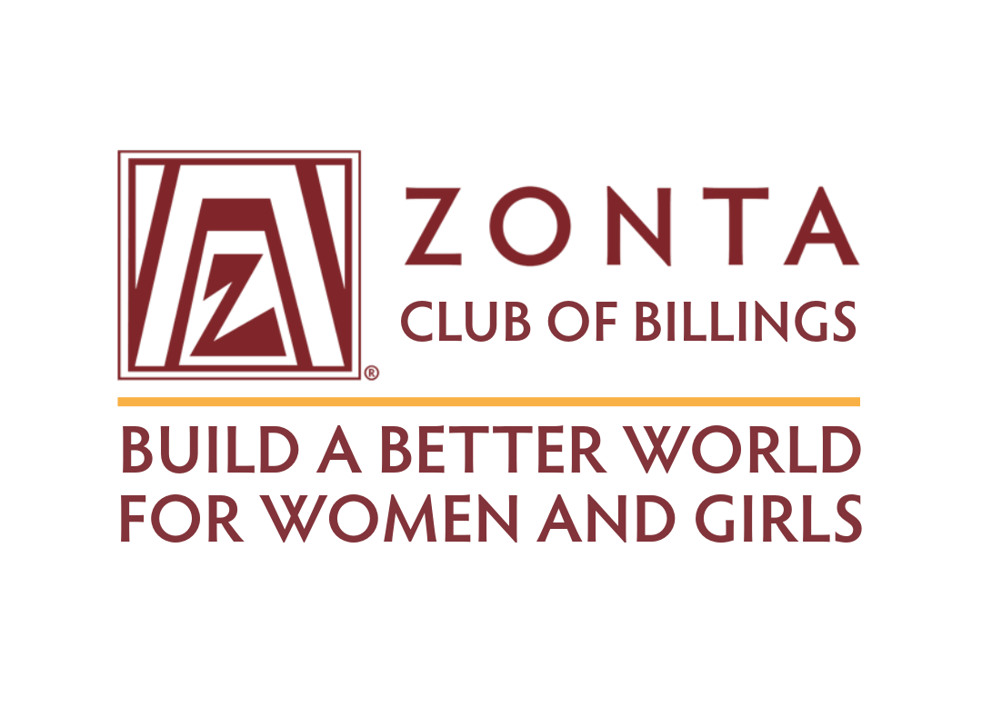
About Trivia Night

GOALS: Proceeds are the essential funds needed for our service and advocacy projects. The Zonta Club of Billings provides service to the community through domestic violence and human trafficking awareness, grants to community agencies, scholarships, and volunteers for local organizations.

IT’S A COMMUNITY EVENT

- This unique, high-energy event attracts about 300 participants and continues to grow annually. It is the primary fundraiser for the Zonta Club of Billings.

- Many of the teams and participants are repeat players.

- It’s an evening of friendly competition and remains one of Billings’ most anticipated and popular fundraising events.

- No experience needed.

- Do I need to be a brainiac? NO! It’s FUN.

- Multiple rounds are structured across various subjects, including general knowledge, history, pop culture, and more.

ABOUT TEAMS

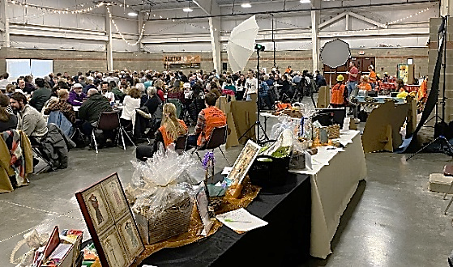
We encourage sponsors to promote team participation among their employees and friends. It’s a great way to spend an evening with coworkers, friends, and test your knowledge while having fun and supporting worthy programs, projects, and opportunities for women and girls.
- Teams consist of 8 people.

- There are 8 rounds of 10 challenging questions.

- Team members are given 1 minute to discuss the question and write down their answer.

- The winning team for each round receives a prize.

- First Place winning team receives a $600 cash prize; 2nd and 3rd place teams earn gift baskets.

WAIT! THERE’S MORE . . .

There’s plenty of time to socialize before and throughout the evening, and opportunities to win prizes between rounds to keep the night exciting.

- 50/50 raffle

- Live and silent auctions

- Door prizes

- Photo booth

- Beer & wine
- Concessions

